Task 1 chunks - curated for a high score.
chunks taken from table chart:
an increase of varying degrees – increased in different levels
with the exception of – not including
that saw no change at all – there was no change
experienced the most pronounced growth – the strongest or most noticeable increase or development
notably – especially; in a way that is easy to notice or stands out
somewhat comparable figures – numbers or data that are fairly similar, though not exactly the same
dramatically – very dramatic
stood out – was clearly different or better than others
recording a change – there was a change
hiking from – rising or increase sharply from one amount to another
boasted more – something that possesses an advantage, feature, or achievement
experienced a sharp – there was a sharp
escalating from – increasing or rising steadily from one level to another
conversely – in an opposite way or on the other hand
remained unchanged – self-explanatory
similar amount registered – self-explanatory
chunks taken from process diagram:
consecutive steps – actions or stages that happen one after another in sequence
divided into three main stages – separate into three major parts or phases
edible portions – parts that can be eaten safely
human intervention – involvement or action taken by people rather than nature
natural processes – changes or actions that occur naturally without human control
potential cocoa trees – trees that have the possibility or capacity to produce cocoa
fully mature – completely developed or grown; ready for harvest or use
tropical countries – nations with a hot and humid climate near the equator
then extracted – removed or taken out from something
which serve as the vital ingredient for chocolate – which act as the most important part used to make chocolate
fermented – allowed to go through a natural chemical process that changes flavor and texture
develop flavor – to gain or form a distinct taste or aroma
spread out – laid out in a wide, flay layer so that air can reach all parts
full exposure – complete contact or openness to something (like sunlight or air)
crispy texture – a firm and crunchy feel when eaten
subsequently under go – to go through a process later or afterward
consistent mixture – a smooth, even blend without lumps or separation
tempering – the process of heating and cooling chocolate to stabilize it and give it a smooth, glossy finish
culminating – ending or reaching the highest or final point
chunks taken from bar chart:
all countries in question – countries being discussed
curtailed their expenses – reduced how much money they spend
steepest drop – the biggest or fastest fall
though it maintained – although it kept the same level or trend
leading – being ahead or most important
notably – especially; in particular
declining pattern – a trend showing a steady decrease
somewhat comparable – fairly similar, though not exactly the same
trailed behind – to be behind another in performance or number
most of the period – during almost the entire time shown
expended significantly more initially – spend a lot more money at the beginning
dedicated around + percentage – used or spend approximately that amount on something
transportation-related services (compound adjectives) – services connected to transport
falling to about + percentage – a drop to a specific figure
similar drop – a decrease that look about the same as another
recorded in + country – where something was observed
plummeted from + percentage – fell very quickly from a certain level
slightly recovering – improving a little after a fall
were found to spend (verb) – data showed they spend a certain amount
latter + noun – the second of two things mentioned
channeled nearly - directed or spend almost that amount of money or energy
dropped by + percentage – decreased by a certain amount
falling back – returning to a lower level after a rise
decline registered in + noun – a decrease was officially seen in something
-a proportion that was not sustained and plunged to a mere + percentage – a number that didn’t stay high and dropped to a very small amount.
remained unchanged despite a notable downward and upward trend – stayed the same overall, even though there were some small decreases and increases
with the most pronounced rise recorded in – the biggest increase happened in
were constantly regarded – were always viewed or considered in a certain way by people
ranked second to – came in the second place after something else; placed right below another category
chunks taken from map chart
work-oriented place – a place mainly focused on working or business activities
minimal facilities – very few or basic services or buildings
significantly multifunctional – used for many different purposes in an important or large way
accommodating a wide range of – providing space or support for many types of things or people
educational facilities – buildings or services used for learning or teaching
notably – especially; in a way that is wroth noticing
transformed area – a place that has been completely changed or improved
adjacent to – next to or very close to something
heart of the area – the central or most important part of a place
since then, however, undergone – means “has experienced a change since that time”
makeover – a complete change or improvement in appearance or structure
subject to change – not fixed; may be changed later.
wide variety of – many different kinds of something
notable change – an important or easily noticed difference
sequentially – happening one after another in order
pursuits – activities that someone does, often for enjoyment or work
used to primarily focus on – in the past, it mainly concentrated on something
used to have a relatively a simply layout – in the past, its layout was quite basic and not complex
significant makeover – a major change or redesign
notably expanded – clearly and noticeably made larger
repositioned – moved to a different place
another alteration – an additional change was made
which had been downsized to accommodate it – something was made smaller to make space for something else
chunks taken from pie chart
increased to varying degrees – went up by different amounts
witnessing the most pronounced growth – experiencing the biggest or most noticeable increase
remaining categories – the other groups that are left
noticeable decline – a drop that can clearly be seen
notably – especially; in particular
significantly lower – much smaller in number or amount
comparable percentages – number that are almost the same or similar
boasted a significantly higher proportion – had a much larger share
positioned education in the third rank – placed education as the third most important or highest
figure dipping – the number going down slightly
conversely – on the other hand; in contrast
saw an upward trajectory – showed a steady rise or improvement
witnessed a sharp rise – experienced a quick and large increase
second largest sector – the industry or category that is second in size
concentrated – focused or gathered in one area
highlighting a significant rise – showing a large increase clearly
accounting for – representing or making up part of a total
saw a minimal increase – had a very small rise.
remaining the least chosen – still being the option selected by the fewest people
chunks taken from line graphs:
exhibited somewhat similar –
age cohorts – age group
experienced rises of varying degrees –
the most pronounced growth –
surpassing –
overtaking –
of particular note –
age demographic –
followed by a temporary decline –
surged to a peak of –
before bouncing back to –
following a relatively similar upward trajectory –
former saw a sharper increase –
reaching a substantial –
albeit to varying degrees and in different patterns –
declined noticeably –
witnessed the most significant rise in popularity –
were chosen more throughout most of the period –
notably –
exhibited a somewhat similar pattern of growth –
latter consistently being the least used means –
demonstrating the slightest growth in the entire dataset –
saw a marked increase –
with the proportion almost doubling to a chart high of 60% -
thereby outpacing cars –
chunks taken from pie charts:
noticeable change –
significant increase –
dramatically decreased –
impressive jump –
largest reduction –
increased dramatically –
saw significant decreases –
more in demand –

SENTENCE STRUCTURE 1 (BIG DIFFERENCE and SMALL DIFFERENCE)
BIG DIFFERENCE
Much, far, significantly, considerably, substantially
1) The salary of teachers in Japan is far more than that of their counterparts in Korea.
SMALL DIFFERENCE
Slightly, marginally, somewhat
2) The number of tourists visiting Samarkand is slightly higher than that of Bukhara
SENTENCE STRUCTURE 2 (BY FAR – SUPERLATIVE)
1) By far the greatest percentage of holidaymakers to Britain opted for AirBnB in 2024.
SENTENCE STRUCTURE 3 (AS … AS)
1) As…adj/adv…as – Compare charts are as difficult as trend charts
2) As much/much noun as – Compare charts pose as much challenge as processes
3) As much/many S+V as – Four times as many students find compare charts difficult as processes
SENTENCE STRUCTURE 4 (DOUBLE THAT OF/TRIPLE THAT OF)
1) The fatality rate on roads in Uzbekistan is nearly double that high-income countries.
2) The number of male high school golfers is almost triple that of female golfers
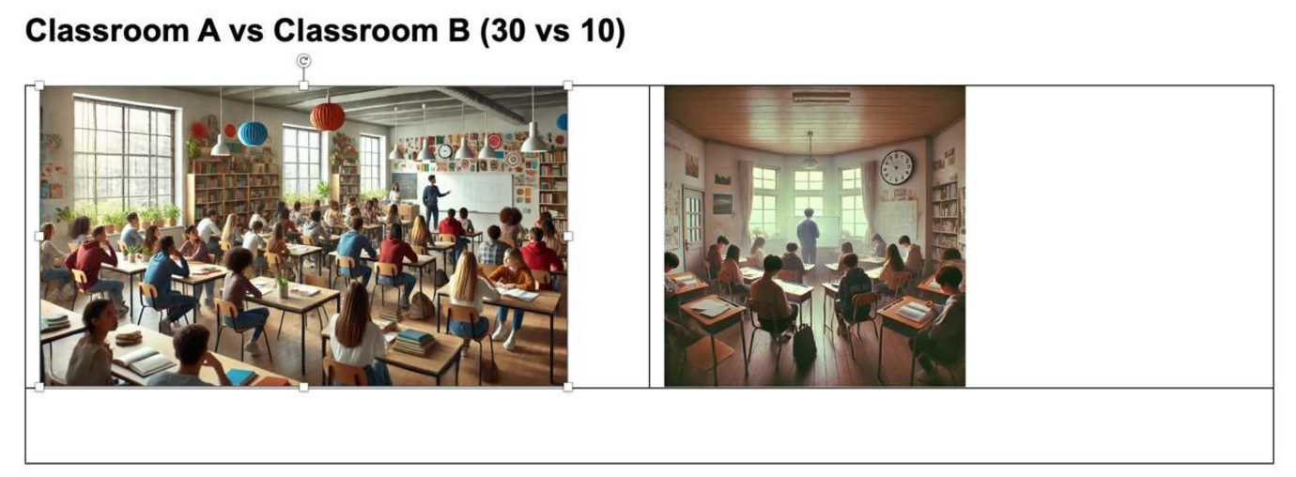
SENTENCE STRUCTURE 6 (DETERMINER)His income is double hers, with respective figures amounting to 40k.
He earns what double what she does.
There are 20 students in the elementary group. That is nearly double the number of students in the intermediate group (9)

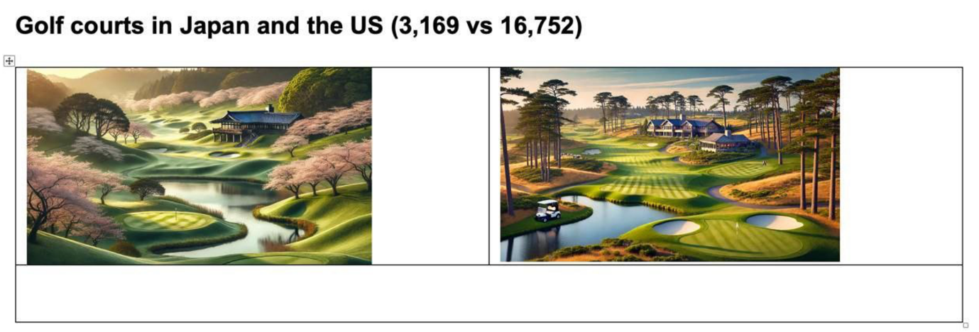
Class A is three times the size of Class B

With 16,752 sites, the US has more than five times the number of next country on the list.
SENTENCE STRUCTURE 7 (APPROXIMATING WORDS)
Nearly, almost, more than, less than, more or less.

SENTENCE STRUCTURE 8 (compared with, compared to, as opposed to, while)
23% of the men in the youngest group exercise daily while 18% of the women in this group do so.
SENTENCE STRUCTURE 9 (FRACTIONS)
25% - a quarter of – 1/4 - one in four – one out of four
33% - a third of – 1/3 – one in three – one out of three
50% - a half of – 1/2 – one in two – one out of two
66% - two-thirds – 2/3 – two in three – two out of three
75% - three-quarters – ¾ - three in four – three out of four
Examples:
23% - nearly a quarter
69% - more than two thirds
47% - nearly a half
78% - just/slightly over three-quarters
SENTENCE STRUCTURE 10 (%/PERCENTAGE)
Common mistakes:
X 15% of time belonged to socializing
X socializing showed/indicated 15%
ACCOUNT FOR / MAKE UP / CONSTITUTE / COMPRISE / TO BE RESPONSIBLE FOR
20% of the time was spent on socializing – choose a verb
Socializing makes up about 20% of leisure time.
About 15% of the population have a PhD.
The proportion of the population with a PhD account for 15%
People with a PhD account for 15% of the population.
Natural gas account for 80% of electricity generation in Uzbekistan.
Natural gas is responsible for 80% of electricity generation in Uzbekistan.
SENTENCE STRUCTURE 11 (RANKING LANGUAGE)
1. in first/second/last place … - in first place is Coca Cola – Coca Cola is in first place (inverted)
2. Top of the list – Top of the list is Coca Cola
3. Bottom/Tail of the list – Tail of the list is Irn Bru
4. The number … - The number-one activity for young people is climbing
5. X is ranked first/second/third with – Wales is ranked second with 45%
6. Next came/Then came – Next came Wales
7. … to be followed by …
Example:
- China is by far the most producer of rice. It is followed by India, which produces only a third of that amount.
- China is by far the greatest produces of rice, followed by India, which produces only a third of that amount
8. X head/top the list – Italy topped the list, its citizens consuming an average of 23 kilograms of pasta annually
9. just head of – Mbappe finished at the top with 8 goals, just ahead of Messi (7)
10. not too far behind – North America generated the highest share of Airbnb’s worldwide revenue in 2023, at 4.6 billion. However, Europe, the Middle east and Africa were not too far behind.
11. come in second/first/fourth place – France comes in a close second place with 44%
RANK + COMPARE SENTENCE STRUCTURE 12 (MAKING IT)
Pepsi came second with 8%, making it only slightly more popular than Fanta (7%)
Level 1 group topped the list with 70% of student success in exam, while group Level 2 came second making it slightly below Level 1 (76%).
SENTENCE STRUCTURE 13 (MODIFYING COMPARATIVES)
use with comparative adjectives like: quite/much/a lot/far/way/a good deal – TO DESCRIBE A BIG DIFFERENCE
The price of a ticket in the USA is quite cheaper than that of New Zealand, at 14% and 21% respectively.
New Zealand had much higher population than the USA
88% of the water is used for agriculture, while the rest 12% is responsible for domestic use – a lot less than agriculture
In map X, the size of a pool was 12 meters deep, which is far shallow than map Y
SENTENCE STRUCTURE 14 (JUST AHEAD OF)
Team sport was the second most popular activity at 54%, just ahead of listening to music, at 53%.
SENTENCE STRUCTURE 15 (while, although, which…)
- Socializing was next at 20%, which was twice as popular as shopping, with 10%.
- Shopping came next at 10%, although this was much less popular than socializing, at 20%.
- Second on the list were team sports at 54% while listening to music was slightly less popular, at 53%.
SENTENCE STRUCTURE 16 (slightly more than the number)
- 54% of people said they played a team sport, slightly more than the number who listened to music, at 53%.
SENTENCE STRUCTURE 17 (poll language)
About 77% of the voters polled said that they are against constitutional change. Another 13% didn’t care
SENTENCE STRUCTURE 18 (age language)
- people between 19 and 24
- people aged between 19 and 24
- people in the 19 to 24 age group
- people between the ages of 19 to 24
- among 19-24-year-olds
- those aged 19-24
- Those in the 19-24 age range/group/category/bracket
- those from the 19-24 age group
- in the youngest/oldest age group
- older/younger people
BODY PARAGRAPHS FOR TREND GRAPHS.
Topic sentence - body1.
- X emerged as the dominant/the most popular/clear front-runner.
- X accounted for the lion’s share of …
- X stood out by demonstrating an exceptionally higher share/percentage/proportion/amount in (year).
Body 2 - topic sentence
- By contrast, the remaining categories showed/exhibited/followed a reverse/downward/upward trajectory.
- Conversely, a reverse pattern of change was observed in the other figures.
- In contrast, the remaining categories saw/experienced/witnessed a reverse trend over the period.
- X and Y, on the other hand, demonstrated a rising/declining pattern of change.
Body structures:
- Starting/beginning the period with …%, the figure for/the percentage of + noun + rose steeply to a chart high of ...%.
- Starting/beginning the period with …%, the figure for/the percentage of + noun + dipped steeply to a mere ...%.
- By the end of the period, X reached the peak of ..% (for an increase)
- By the end of the period, X fell to its lowest point of ..%.
- Similarly, the figure for Y declined/grew gradually from .. to …
- A similar pattern of growth/decrease was evident in/observed in… , with the figure declining/rising from .. to..
- Unlike X and Y, Z saw a temporary/brief rise/decline in the mid-period from …% to ..% before rising/decreasing to… %
- The percentage of X fell from .. % to …% before/prior to returning to its initial level/ /bouncing back (recovering after a fall)
- The most pronounced/the sharpest/the most notable/substantial/significant/considerable rise/drop was recorded in…, with
- After a slight dip/rise to.., the percentage/amount of X experienced growth/drop to…%
- Having levelled off at ..%, the figure began to decline/rise to… %.
- Following a brief fall, the percentage recovered to …%.
- Despite a short-term drop, the figure rose again, reaching …%.
Overview for trend graphs
- You need identify what went up and went down/remained the same
- You should mention the highest figure or the figure that surpassed other categories.
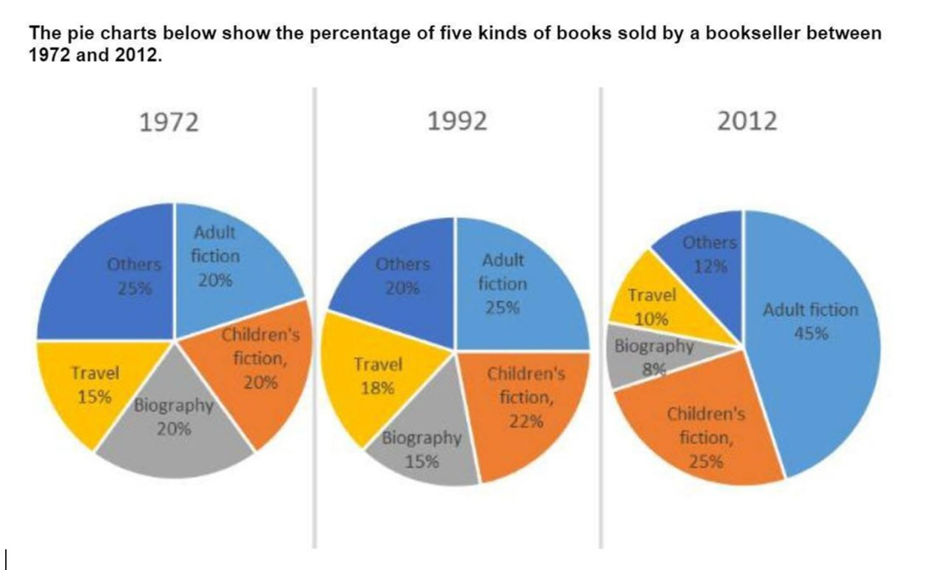
- The lowest figure

Overall, children’s and especially adults’ fiction rose over the period, while the remaining categories followed a decline of varying degrees. Adults’ fiction became the bestseller, surpassing ‘other’ genres by 2012. Notably, the lowest proportion was observed in biography and travel.

STRUCTURES.
Trend graphs: change over time.
Overall, … and … rose/declined over the period, while the remaining categories followed an upward/a downward trend. X became the clear leader/highest, surpassing Z. Notably, Y and B accounted for the lowest shares/amount/percentage.

Comparative graphs: comparison across categories
Overall, X and Y recorded higher figures for A, whereas the remaining categories showed stronger levels of B. Z was the largest importer of A. Notably, C accounted for the lowest amount of A, at a level comparable to D’s B figure.
Sentence 1 → big picture / grouping
Sentence 2 → leader + comparison
Sentence 3 → lowest / notable point
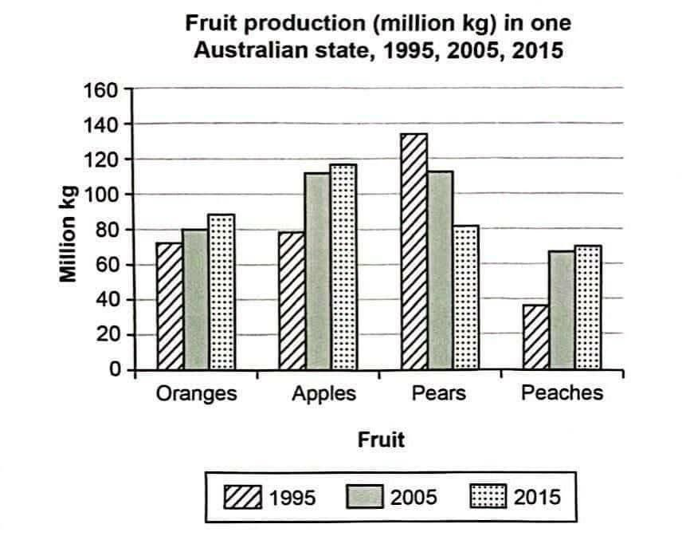
The amount > the level of production/the volume of production/the output of pears.

Overall, all types of fruits increased in their production to varying degrees, except for pears, which experienced a dramatic decline. In 1995, pears were produced in large volumes, but apple production surpassed them by the final year. Notably, peaches accounted for the lowest level of output throughout the period.
X was the clear leader throughout the period/timeframe.

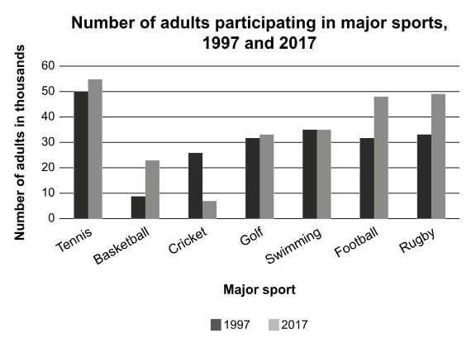
Overall, most sports activities followed a upward trend, whereas cricket and swimming were exceptions, whose figures either declined or remained unchanged. Tennis was the most popular activity throughout the period, while cricket became the least chosen sports.

